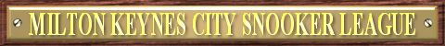
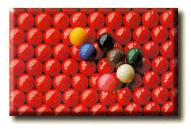

2007-2008 SEASON FIXTURES

 | Instructions |  |  |  |  |  | Premier A  Division |  | Away Team
Match Date |  | Match Number | Match Date | Match Number |  |  | Premier A  Division | BCC Hawks |  | Herald Breakers | MKSC Jedi | MKSC Matchroom | R.B.L | The Firm | The Hunters | Wolverton Warriors
17/09/2007 |  | Match 1 | 14/01/2008 | Match 1 |  |  | 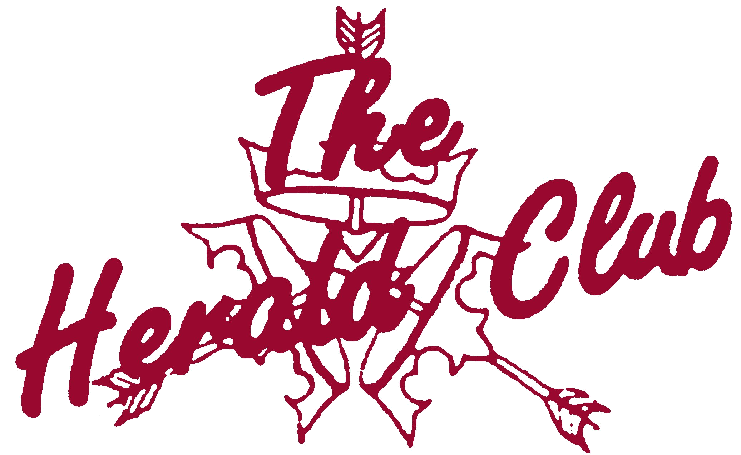  Sponsored by:
24/09/2007 |  | Match 2 | 21/01/2008 | Team Knockout R2
01/10/2007 |  | Match 3 | 28/01/2008 | Match 2
08/10/2007 |  | Match 4 | 04/02/2008 | Match 3
15/10/2007 |  | Match 5 | 11/02/2008 | Match 4
22/10/2007 |  | Match 6 | 18/02/2008 | Match 5
29/10/2007 |  | Match 7 | 25/02/2008 | Match 6
05/11/2007 |  | Match 8 | 03/03/2008 | Match 7
12/11/2007 |  | Match 9 | 10/03/2008 | Match 8
19/11/2007 |  | Match 10 | 17/03/2008 | Match 9 |  |  | Home Team
26/11/2007 |  | Match 11 | 31/03/2008 | Match 10 |  |  | BCC Hawks |  |  | 7 | 8 | 13 | 2 | 11 | 5 | 3
03/12/2007 |  | Match 12 | 07/04/2008 | Match 11 |  |  | Herald Breakers | 14 |  |  | 6 | 11 | 10 | 5 | 8 | 2
10/12/2007 |  | Match 13 | 14/04/2008 | Match 12 |  |  | MKSC Jedi | 1 |  | 13 |  | 3 | 5 | 9 | 7 | 11
17/12/2007 |  | Match 14 | 21/04/2008 | Match 13 |  |  | MKSC Matchroom | 6 |  | 4 | 10 |  | 8 | 14 | 2 | 12
07/01/2008 |  | Team Knockout R1 | 28/04/2008 | Match 14 |  |  | R.B.L | 9 |  | 3 | 12 | 1 |  | 6 | 4 | 14
Use the Match Date to find the Match Number above. On your division’s grid, where your team aligns, find the Match Number. The aligned teams are playing each other. |  |  |  |  |  |  | The Firm | 4 |  | 12 | 2 | 7 | 13 |  | 10 | 8
 |  |  |  |  |  |  | The Hunters | 12 |  | 1 | 14 | 9 | 11 | 3 |  | 6
 |  |  |  |  |  |  | Wolverton Warriors | 10 |  | 9 | 4 | 5 | 7 | 1 | 13

Premier B  Division |  | Away Team |  |  |  |  |  |  |  |  |  | First  Division |  | Away Team
 | Ball Breakers |  | Cranfield SC A | Herald Hotshots | MKSC Knights | MKSC Potters | MKSC Rockets | MKSC Whirlwins | SSCC A |  |  | First  Division | BCC Tornadoes |  | Incrediballs | Legionaires | MKSC Windowcraft | Pury Potters | SSCC B | The Buckingham Bandits | The Turtle Heads
  Sponsored by: |  |  |  |  |  |  |  |  |  |  |  | Sponsored by:
Home Team |  |  |  |  |  |  |  |  |  |  |  | Home Team
Ball Breakers |  |  | 10 | 12 | 13 | 2 | 8 | 4 | 7 |  |  | BCC Tornadoes |  |  | 7 | 12 | 4 | 10 | 2 | 13 | 8
Cranfield SC A | 3 |  |  | 14 | 9 | 4 | 12 | 6 | 1 |  |  | Incrediballs | 14 |  |  | 9 | 6 | 1 | 12 | 4 | 3
Herald Hotshots | 5 |  | 7 |  | 1 | 10 | 4 | 9 | 13 |  |  | Legionaires | 5 |  | 2 |  | 10 | 13 | 11 | 8 | 7
MKSC Knights | 6 |  | 2 | 8 |  | 14 | 10 | 12 | 4 |  |  | MKSC Windowcraft | 11 |  | 13 | 3 |  | 5 | 8 | 7 | 2
MKSC Potters | 9 |  | 11 | 3 | 7 |  | 13 | 1 | 5 |  |  | Pury Potters | 3 |  | 8 | 6 | 12 |  | 14 | 2 | 11
MKSC Rockets | 1 |  | 5 | 11 | 3 | 6 |  | 14 | 9 |  |  | SSCC B | 9 |  | 5 | 4 | 1 | 7 |  | 10 | 13
MKSC Whirlwins | 11 |  | 13 | 2 | 5 | 8 | 7 |  | 10 |  |  | The Buckingham Bandits | 6 |  | 11 | 1 | 14 | 9 | 3 |  | 5
SSCC A | 14 |  | 8 | 6 | 11 | 12 | 2 | 3 |  |  |  | The Turtle Heads | 1 |  | 10 | 14 | 9 | 4 | 6 | 12

Second  Division |  | Away Team |  |  |  |  |  |  |  |  |  | Third  Division |  | Away Team
 | Buckingham SC A |  | Herald Hornets | Herald Spiders | MKSC Allsorts | MKSC Five Steps | MKSC Inoffs | MKSC Stompers | The Tackers |  |  | Third  Division | BCC Comets |  | Bye | Cranfield Tigers | Herald Cue Smashers | Herald Potters | MKSC Old Codgers | Off The Cush | Wolverton Ammers
  Sponsored by: |  |  |  |  |  |  |  |  |  |  |  | Sponsored by:
Home Team |  |  |  |  |  |  |  |  |  |  |  | Home Team
Buckingham SC A |  |  | 2 | 10 | 13 | 7 | 4 | 8 | 12 |  |  | BCC Comets |  |  | 11 | 1 | 6 | 3 | 9 | 14 | 5
Herald Hornets | 9 |  |  | 4 | 7 | 3 | 13 | 12 | 1 |  |  | Bye | 4 |  |  | 12 | 2 | 8 | 14 | 6 | 10
Herald Spiders | 3 |  | 11 |  | 5 | 8 | 2 | 6 | 14 |  |  | Cranfield Tigers | 8 |  | 5 |  | 10 | 13 | 11 | 2 | 7
MKSC Allsorts | 6 |  | 14 | 12 |  | 2 | 8 | 10 | 4 |  |  | Herald Cue Smashers | 13 |  | 9 | 3 |  | 7 | 1 | 12 | 4
MKSC Five Steps | 14 |  | 10 | 1 | 9 |  | 12 | 4 | 6 |  |  | Herald Potters | 10 |  | 1 | 6 | 14 |  | 12 | 4 | 9
MKSC Inoffs | 11 |  | 6 | 9 | 1 | 5 |  | 14 | 3 |  |  | MKSC Old Codgers | 2 |  | 7 | 4 | 8 | 5 |  | 10 | 13
MKSC Stompers | 1 |  | 5 | 13 | 3 | 11 | 7 |  | 9 |  |  | Off The Cush | 7 |  | 13 | 9 | 5 | 11 | 3 |  | 1
The Tackers | 5 |  | 8 | 7 | 11 | 13 | 10 | 2 |  |  |  | Wolverton Ammers | 12 |  | 3 | 14 | 11 | 2 | 6 | 8


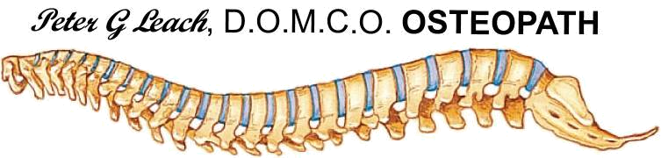

The MKCSL would like to thank all this seasons sponsors:


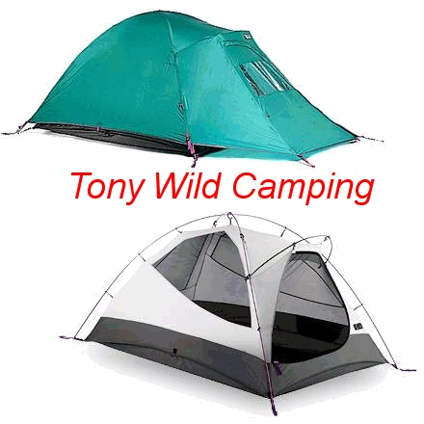
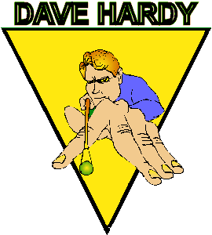

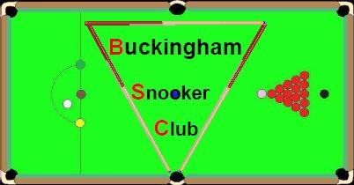

For more information about the Milton Keynes City Snooker League visit the League’s web site at www.mkcsl.co.uk

